**Memory story books unit**

Hailey Wasden and Eledy Gomez

# Objective Statement

Students will learn they can create story books like the ones they read in school and at home. Students will learn how to create art pieces that directly correlate with the words they have written in response to the memory prompt. They will learn how to use multiple mediums to create one art piece.

# Lesson Overview

1. Lesson title: Memory Books
2. Enduring Ideas: Memory, collaboration
3. Grade/Level: KG-2nd
4. Objective statement: Students will learn they can create story books like the ones they read in school and at home. Students will learn how to create art pieces that directly correlate with the words they have written in response to the memory prompt. They will learn how to use multiple mediums to create one art piece.
5. Time Allotment: 5 class periods

# Rationale

We would like students to participate in this lesson to allow them to create their own story book. Most young children consume art through story books in their everyday life, so creating one of their own should be exciting for them. Showing students that they are capable of creating things that are similar to the story books they love will encourage students to create more. Showing students that they can use multiple mediums and combine them to create art pieces will give them new ideas for artwork, and can influence their use of multiple mediums in future artwork.

| **National Standard(s)** | **TEKS: (Min. 2)** | **Objective(s)** | **Assessment(s) (Demonstrate Mastery)** |
| --- | --- | --- | --- |
|  | * Art -TEK-2.2 Creative expression. * The student communicates ideas through original artworks using a variety of * media with appropriate skills. The student expresses thoughts and ideas creatively while challenging the imagination, fostering reflective thinking, and developing disciplined effort and progressive problem-solving skills. The student is expected to: * (A) express ideas and feelings in personal artworks using a variety of lines, * shapes, colors,textures, forms, and space; * (B) create compositions using the elements of art and principles of design | Students will learn they can create story books like the ones they read in school and at home. Students will learn how to create art pieces that directly correlate with the words they have written in response to the memory prompt. They will learn how to use multiple mediums to create one art piece. | Ensuring that their visual response matches the given assignment, and that the prompts have been followed as given. Their end product should be an organized journal. |

| **Modification** |
| --- |
| No corrections for spelling or grammar.  Less pages to fill out.  Pre-cut items to glue on.  Less harsh grading on the correlation between the visual and written prompt. |
| **Extension** |
| have more pages in the book for students.  Addition of more abstract prompts.  They can include more information and be given more space to let their imagination flow.  Students are assigned to make a table of contents for their book. |

| **Materials/**  **Resources** | 1. Pre printed and assembled books 2. stapler 3. Scissors for each table of students (optional - only needed if teacher is allowing students to cut out their own collage material) 4. Magazines, newspapers, other collage materials (optional - only needed if teacher is allowing students to cut out their own collage material) 5. Colored pencils for each table of students 6. Crayons for each table of students 7. Pencils with erasers for each table of students 8. Glue sticks for each table of students 9. Storybooks: *The Very Hungry Caterpillar* by Eric Carle (<https://www.youtube.com/watch?v=021xLvsAIm4&t=2s>) 10. Storybooks: *Brown Bear, Brown Bear, What Do You See?* By Bill Martin Jr. (<https://www.youtube.com/watch?v=WST-B8zQleM>) |
| --- | --- |

# Implementation

Students will learn they can create story books like the ones they read in school and at home. Students will learn how to create art pieces that directly correlate with the words they have written in response to the memory prompt. They will learn how to use multiple mediums to create one art piece. The material and the procedure will be reviewed again with the students to ensure they understand the material they need to use and what the assignment requires.

## **Procedure**

1. Students will illustrate and author their own small story book based on memories they have made throughout the school year.
2. Students will illustrate and author their own small story book based on memories they have made throughout the school year.
3. The teacher can pre-print the book pages before introducing the lesson, and fold and staple them before handing them out to students to fill in. The teacher will present the project to students before handing out the books, and discuss story books and how the illustrations in the book go with the words of the page.
4. The teacher will monitor students and check to ensure their understanding of the assignment and offer extra help as needed. Through the work days the teacher will assist in the creation of the art pieces both in creating and in relation to prompt.
5. After discussing some of the prompts and ideas for responses to them, the teacher will pass out the books for students to begin writing responses. Students will write their responses to all prompts before beginning on the art pieces that go with them.
6. When the books are completed with words and pictures, students can share with the class. The final assessment of this lesson is how well the student performed in creating an art piece response that goes along with the word response to the prompts in the books.

# Assessment

The completion of the memory book, making sure that the prompts are according to what was given. The students will also participate in a self-grading rubric activity.

# Day by day plan

**Day One:**

(pre-prep: print off pages and assemble and staple books - one for each student. Length of books and complexity of prompts should vary based on age group and abilities of each individual class)

* Teacher presents the project to the class. (The slideshow we would present to students is within our presentation materials)
* Teacher shows examples of story books with pictures EX. Eric Carle *The Very Hungry Caterpillar*
* Teacher introduces the concept of mixed media and collage and shows examples of collage artwork.
* Hand out books for students to look at and begin brainstorming
* Teacher directs discussions with the class about the project, the prompts for memories in the books, possible answers to the prompts, and ways to make art pieces that answer the prompts.
* (Depending on the length of class periods, students may have time to begin writing their responses to the prompts in the lines on each page.)
* At the end of class, students should store their books in a basket provided by the teacher that is specifically for the books from their class period to avoid the book getting lost or damaged.

**Day Two:**

(pre-prep: set up supplies for students to use to create their artwork in the books. Depending on age group and individual class, teachers may do some pre-cutting of magazines for collage for students to use in their books without being responsible for cutting with scissors.)

* Teacher introduces what expectations are for the day: students should be working on writing short answers to the prompts before creating the artwork for that page.
* The Teacher will actively walk around class checking on students' work and progress, helping students to respond to the prompts properly, spell words correctly, and create short answers in general.
* (depending on the length of class period, students may be able to begin planning and executing their artwork for each page.)
* At the end of class, students should store their books in a basket provided by the teacher that is specifically for the books from their class period to avoid the book getting lost or damaged.

**Day Three:**

(Pre-prep: set out materials once again, all set up that you may need for students to begin their art pieces in the books)

* Teacher introduces expectations for the class day: Students should be finished with or close to finished with the writing in response to the prompts. Majority of the day should be spent working on creating the artworks that will illustrate the students' responses to the prompts.
* To keep students engaged and stay on task, students will take a break and the teacher will read the book titled *Brown Bear, Brown Bear what do you see, by Bill Martin Jr.* After the brain break students will return to their seats.
* The teacher will actively walk around the class, helping students with completing their writings, and beginning their art works. Teachers will help students come up with ideas for their artwork based on their written responses , and will help the students to employ multiple medias into the artwork.
* At the end of class, students should store their books in a basket provided by the teacher that is specifically for the books from their class period to avoid the book getting lost or damaged.

**Day Four:**

(pre-prep: set out materials once again, all set up that you may need for students to continue progress on their art pieces in the books)

* Teacher introduces expectations for class that day:There will be a review of examining story books and their artwork to have students do more than just work on projects all class period, to avoid boredom and restlessness. After discussion, students should all be working on their art pieces in the books. Majority of the day will be a work day for creating the art pieces in the books.
* Teachers will actively walk around the classroom continuing to help students with creating their art pieces in their books. Helping students move along towards completing their art pieces to allow for more time in the next class period for sharing and presenting.
* At the end of class, students should store their books in a basket provided by the teacher that is specifically for the books from their class period to avoid the book getting lost or damaged.

**Day Five**

(pre-prep: Set out materials students may need to finish working on their books and any preparations necessary for the presenting and sharing process, like a talking piece or other class-specific preparations)

* The Teacher will present expectations for the class day to students: Students will finish up their art works , leaving enough time for sharing, and the self assessment rubric.
* The Teacher will actively walk around the class to help students completing their books, finishing up last touches.
* After students have had some time to finish up their artworks, the teacher will have them clean up at their tables, and then allow them to volunteer to present and share some of their favorite memories and their artwork.
* At the end of class, students should store their books in a basket provided by the teacher that is specifically for the books from their class period for the teacher to grade before handing back to students at a later time for them to take home with them.

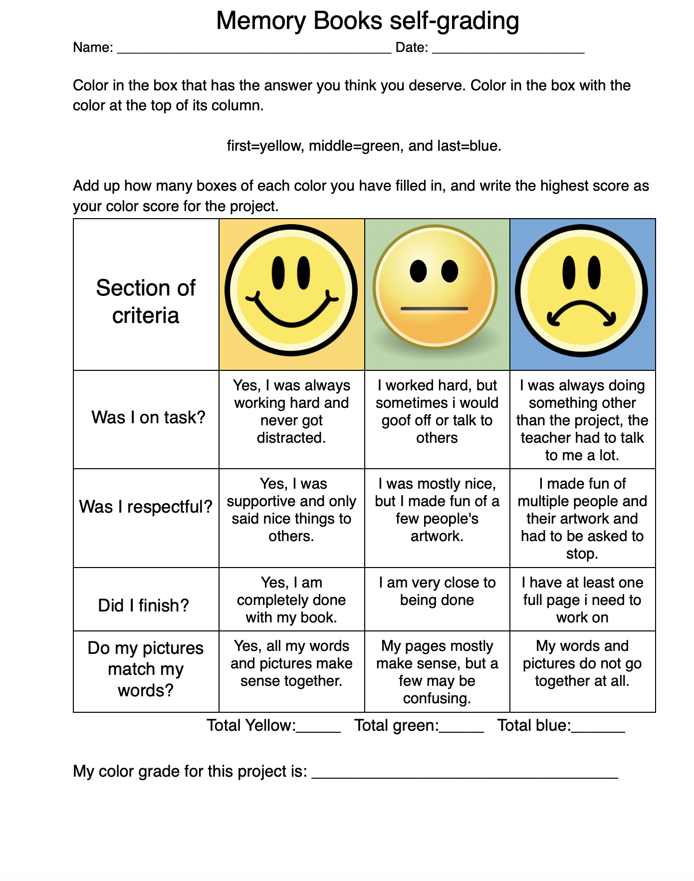

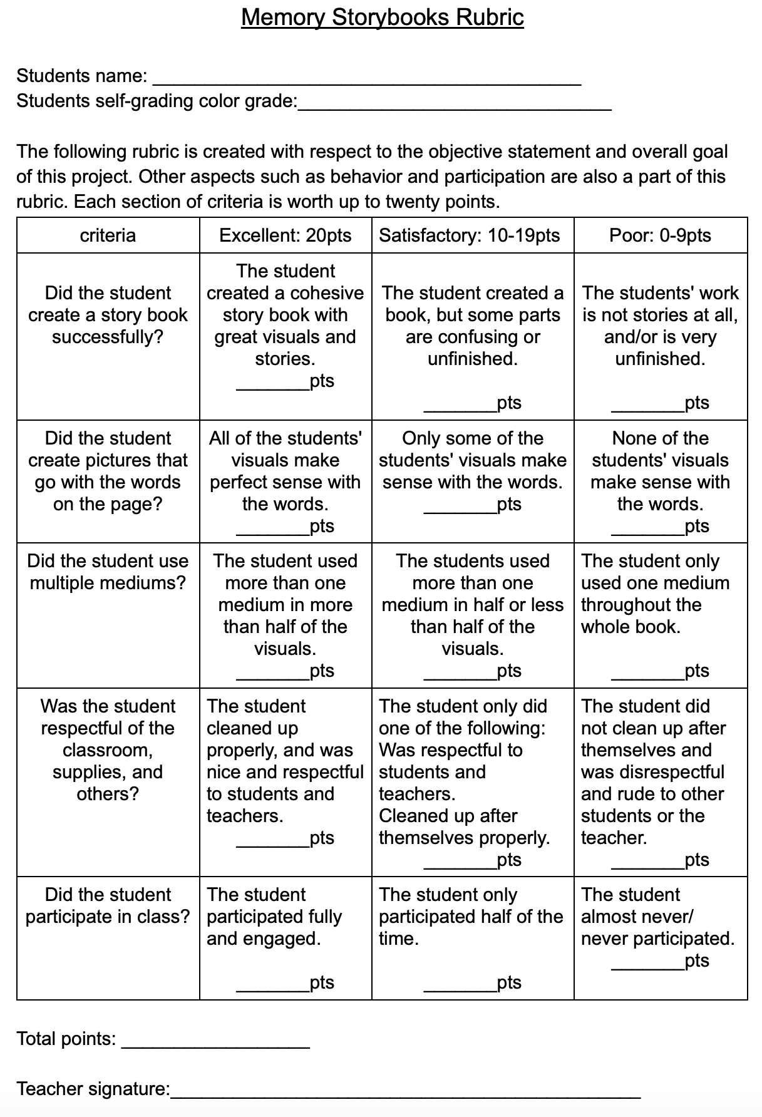

**Pages of book to print off:**

